**Online Food Store Platform**

**Requirements specification**

Contents

1.Introduction 3

1.1Purpose 3

1.2Background 3

1.3Scope 3

2. System Definition 4

2.1Project Origins & Background 4

2.2User Characteristics 4

2.3Project Objectives 4

3.Application Environment 4

3.1The Network Environment 5

4.Functional specification 5

4.1Role Definition 6

4.1.1Customer 6

4.1.2Administrator 6

4.1.3DataBase 6

4.2The Main Use Case Diagram 6

4.3Client Subsystem 7

4.3.1User Login 10

4.3.2Browse & Select Product 10

4.3.3Add to Cart 10

4.3.4 Confirm or Modify Consignee Information 11

4.3.5 Payment 11

4.4 Administrator Subsystem 11

4.4.1 Admin Access 12

4.4.2 Product Management 13

4.4.3 Menu Management 13

4.4.4User Management 13

4.4.5Product Promotion Management 14

4.4.6Report Management for the Admin 14

5. Performance Requirements 14

5.1 Interphase Requirement 14

5.2 Response-time requirements 15

5.3Reliability Requirements 15

5.4 Openness Requirements 15

5.5 Extensibility Requirements 15

5.6Security Requirements 15

# 1.Introduction

## 1.1Purpose

This document is about user for online food store platform functionality and performance requirements, mainly describes the function of the online food store platform requirements. This document is an important input in the conceptual design phase.

The intended audience for this document is:

* The designer
* The developer
* Project manager
* The tester
* The user

## 1.2Background

Name of Software : Online Platform for Food Store

Development unit: NEWBIE

Project Member: David Wade Tim Eric

User: The customer of “Eat & Joy” Company

## 1.3Scope

The document is a logical model of the current system that exports the logical model of the target system to solve the problem of "what to do" throughout the project system. At there, it does not involve development technology, and mainly through the establishment of model to describe the needs of users, for the customer, the user and developer divide different parties provide a communication platform.

# 2. System Definition

## 2.1Project Origins & Background

The “Eat & Joy” company has been selling different types of food since 2006 and most of the sales are done through outlet stores. The company decides to have an online presence and hence would like to develop a platform to transform their offline business to online.

## 2.2User Characteristics

The users of this system are online users, including two categories, one classes is the shopper, have a great of different, have different degree from high and low and age has the young or old else. The other type of user is the administrator, who is responsible for the shelves and the daily maintenance of the site.

## 2.3Project Objectives

Developing a basic feature online platform selling and promoting baby product by identifying the use of different technology to meet a specific set of web application requirements.

# 3. Application Environment

According to the user's statement of requirements, the project can be identified as client and management. The client which serves for shopper can registers, log in, edit the personal information, select the item to purchase, and put it in the shopping cart, and confirm the order and so on. The management is service for administrator, It have some function such as product management, menu management. User management, product promotion management and other functions

The client diagram is shown in figure a-1。

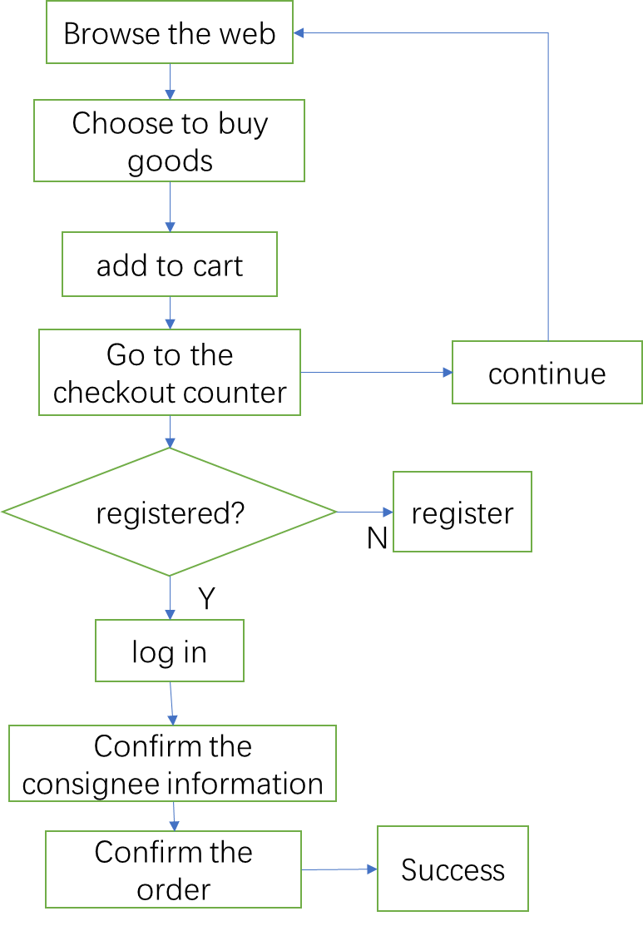

Drawing A-1

## 3.1The Network Environment

Both the shopper on the client side or management, administrator can log in to the system via the network. Shoppers browse through the Internet for information, submit orders for goods, pay for goods, etc., and the administrator publishes information on the Internet via the Internet, according to order delivery.

## 4.Functional Specification

We use object-oriented analysis as the main system modeling approach, using UML as the modeling language. UML provides a variety of feature methods for observing and presenting systems from different perspectives for modeling activities. In UML, from any Angle on the system of abstract may need several models to describe, and these model diagram from different Angle of the image of the system.

The use-case Description role (user, external system, and system processing) is how make you interact with the system to get the job done. Use case model provides a very important way and defining system functions to define the boundaries of the system, at the same time, the model to derive a dynamic object model in the future.

When designing use cases, we follow the under steps:

Identify the role of the system. The role can be a user, an external system, or even external processing, interacting with the system through some ways. The important thing is to focus on the external actors from the system to describe what the system needs to provide, and pointed out that who is the Actor (role) of these functions. Make sure that all roles can fully identified.

1. Describe the main use cases. You can take some ways for such constantly ask yourself, "what does this character want to do with the system?" so that can describe the use cases accurately.
2. Review each use case for the next detailed definition.

## 4.1Role Definition

A role or Actor is an external user or external system that interacts with the system.

### 4.1.1Customer

Shoppers refers to in the online shopping system by the client to submit orders, the role is mainly responsible for the client's browsing goods, order goods, and other functions.

### 4.1.2Administrator

Administrator is to point to in the online shopping system through the management of commodity information, the role is mainly responsible for managing the add goods, modification of goods, etc.

### 4.1.3DataBase

A database is an external system that interacts with the system, which is responsible for the system's data queries, additions, deletions, and modifications.

## 4.2The Main Use Case Diagram

The shopping system can be divided into two main components, The one is client terminal system and other one is the management terminal system. The function of the customer terminal system mainly refers to the function of the shopper to operate on the shopping website, namely the function of shopping. The function of managing terminal system mainly refers to the function of the administrator to perform operation on the commodity, namely, the function of management, by logging on to the shopping website.

The main use case diagram for the system is shown in figure A minus 2.



图A-2

## 4.3Client Subsystem

Customers browse the goods through the online shopping system, He or she can land system and put in the shopping cart what want to buy, and then to pay ,of course you should confirm the consignee information, submit orders, that all you finished goods order. Its activity diagram is shown in figure a-3.



The client use case diagram is shown in figure a-4.



图A-4

client-side is shown Use-Case Description:

F-C-1: Log in/register. Customers must log on to the site before they buy a product, and if they do not register, they will not be able to use the site's purchase function.

F-C-2: Browse and search for goods. Customers can view the details of any product from the home page using a variety of filters and search boxes.

F-C-3: Maintain shopping cart. After selecting a product, the customer can put the item in the cart, and the cart displays the name of the item, the unit price, the quantity, the total price of the goods, and so on.

F-C-4: View and maintain personal information. Customers can change personal information such as avatar, contact information, and password, as well as view transaction records.

F-C-5: Payment. The user will pay through the online bank after confirming the order information.

### 4.3.1User Login/Logon

Only after landing can the customer complete the purchase. No landing system users can only browse, choose goods or the goods add to cart, to fill in information of the consignee or the payment, submit orders need to log in. If the user does not register to register, the user can log in.。

Use-Case Description: User Login/Logon

Actor: customer

Preconditions: Users open the shopping system through the Webpage.

Postconditions: Only after landing, you can payment or operate your orders.

Base Path:

1. Customers open the online shopping system
2. Enter the user name and password in the login box, and click ok to log in

### 4.3.2Browse & Select Product

Customers through websites to browse, they can search for information, and select what they want to buy.。

Use-Case Description: browse、select merchandise.

Actor: Customer

Preconditions: Customers open the browse.

Postconditions: Customers select the merchandise what they want to buy.

Base Path:

a) When customers open the shopping online system it can display vary merchandises and information about those merchandise.

b）Use a variety of filters and search boxes to view the details of any product .

### 4.3.3Add to Cart

The customer can put the selected goods in the shopping cart and then continue to select the next goods. The shopping cart is used to save the information about goods that the customer selected.

Use-Case Description: Put in shopping cart.

Actor: Customer

Preconditions: Customer have selected goods.

Postconditions: You can payment which in the shopping cart.

Base Path:

a）Customer should put in the shopping cart what they selected.

b）Continue to pick up items or go to the checkout counter.

### 4.3.4 Information Management

Customers can update their personal information after registering

Use-Case Description: Confirm or Modify Consignee Information

Actor: Customer

Preconditions: The customer has registered.

Postconditions: The modified personal information is stored in the database.

Base Path:

a) Customers select personal information

b) The ensure information is stored in the database and updated.

### 4.3.5 Payment

The customer can pay for the payment in the way that the online bank pays.

Use-Case Description: Payment;

Actor: Customer

Preconditions: The customer has identified the consignee information.

Postconditions: Select the payment method to confirm the order and submit the order to complete the product.

Base Path:

a）The customer enters the payment page

b）Choose online bank to pay.

## 4.4 Administrator Subsystem

The admin can log in to control the Product Management, Menu Management, User Management, Product Promotion Management and Report Management for the Admin function.

The administrative use case diagram is shown in figure a-5.



图A-5

Management is Use-Case Description under:

F-M-1: Admin Access: Administrators can only perform their administrative

functions after logging in.

F-M-2: Product Management: Administrators is able to manage the information

about the product and add descriptions for each product.

F-M-3: Menu Management: Administrator is able to manage the menu content and

add the URL for the link page for the new menu item.

F-M-4: User Management: Administrator is able to manage the customer's account

and relevant information.

F-M-5: Product Promotion Management: Administrators is able to manage the

promotion and promotion of products and import existing products from excel tables.

F-M-6: Report Management for the Admin: Administrator should product and category wise sales report on a daily basis / Weekly / Monthly/ Annually

### 4.4.1 Admin Access

Administrators log on to the administrative side as a system administrator and have administrative permissions only after logging in.

Use-Case Description: Admin Access

Actor: administrator

Preconditions: The administrator opens the online shopping system through the

browser

Postconditions: After the landing manager, the order, the product, and the user's

management can be made.

Base Path:

1. Administrators open the online shopping system;
2. Enter the user name and password in the login box, and click ok to log in。

### 4.4.2 Product Management

Administrators is able to manage the information about the product and add descriptions for each product.

Use-Case Description: Product Management

Actor: administrator

Preconditions: The administrator has logged into the system

Postconditions: The resulting product information will be recorded in the database

Base Path:

* + 1. Food Menu management for different categories such as CRUD (Create / Read / Update / Delete)
    2. For any item, there should be at least 6 different pictures for users to see on the product information page.
    3. Customers can rollover on the image to experience the zooming affect
    4. Should define the quantity available in stock for every item that gets updated whenever a customer purchases it
    5. Add description to every item

### 4.4.3 Menu Management

Administrator is able to manage the menu content and add the URL for the link

page for the new menu item.

Use-Case Description: Menu Management

Actor: administrator

Preconditions: The administrator has logged into the system

Postconditions: The updated menu will be displayed on the main page

Base Path:

* 1. Admin should be able to control the menu on the Home page from the admin control
  2. Can Edit/Delete /Add any new menu to the home page
  3. When an Admin adds a new menu, he should also be allowed to add the URL of the web page that the menu will be directed to whenever user clicks the web link

### 4.4.4User Management

Administrator is able to manage the customer's account and relevant information.

Use-Case Description: User Management

Actor: administrator

Preconditions: The administrator has logged into the system

Postconditions: The compiled user information will be recorded in the database

Base Path:

* 1. Can view details of all the registered users
  2. Filter list of users based on a range of date
  3. Top 20 users for a month / day / week.

### 4.4.5Product Promotion Management

Administrators is able to manage the promotion and promotion of products and import existing products from excel tables.

Use-Case Description: Product Promotion Management

Actor: administrator

Preconditions: The administrator has logged into the system

Postconditions: The promoted promotion will be recorded in the database

Base Path:

* 1. Admin can create promotion policy such as Date of promotion / Promotion Title such as New Year Sales etc., set percentage of discount for any product in that case, the pages displays both the actual price and the discount price along with the date till which the discount is valid
  2. Update / Delete / View all the promotions
  3. Import existing Product details from Excel Sheet

### 4.4.6Report Management for the Admin

Administrator should product and category wise sales report on a daily basis /

Weekly / Monthly/ Annually

Use-Case Description: Report Management for the Admin

Actor: administrator

Preconditions: The administrator has logged into the system

Postconditions: The generated reports will be logged in the database

Base Path:

* 1. Product and category wise sales report on a daily basis / Weekly / Monthly/ Annually
  2. Should be able to view sales report based on a given range of dates
  3. Export the report to Excel

# 5. Performance Requirements

According to the user's requirements of the system, the system has high performance requirements in response time, reliability and safety.

## 5.1 Interphase Requirement

Home page requirements

* 1. Should display list of different category of products
  2. Should display details of some top 20 hot selling product that may belong to any category
  3. Should display top 20 products that are recently added to the list
  4. Users should have a filter to display products based on high to low price range.
  5. Not more than 20 products are displayed at a time on the page
  6. Users can type any keyword to look for that product
  7. Users may be allowed to define their category and type keyword for searching product in that category
  8. Home page should randomly display some 5 pictures of the product or models just below the menu of the home page
  9. The home page displays Menu at the top and some details at the bottom of the page
  10. The Login box at the top right corner of the home page
  11. The company logo at the top left corner of the home page
  12. Just below the Picture gallery, should be the Filter and the search for the user to look for what they want.

## 5.2 Response-time requirements

The system should respond in a timely manner when the user logs in, whether it is the client or the administrative side, and the response time is within five seconds. System shall be able to detect all kinds of abnormal conditions, such as the communication interrupt, and equipment cannot connect to the database server, etc., to avoid waiting for a long time and even no response。

## 5.3Reliability Requirements

The system should be able to ensure that there is no downtime in 7 times 24 hours, so that 20 people can log in at the same time at the same time.

## 5.4 Openness Requirements

The system should be flexible enough to accommodate the need for future functional extensions.

## 5.5 Extensibility Requirements

The design requirements of the system can reflect the requirements of extensibility to accommodate future expansion.

## 5.6Security Requirements

The system has strict authority to manage function, each functional module needs to have corresponding authority to be able to enter. The system can prevent the data loss and destruction caused by various kinds of disoperation. Prevent users from illegally obtaining web pages and content.